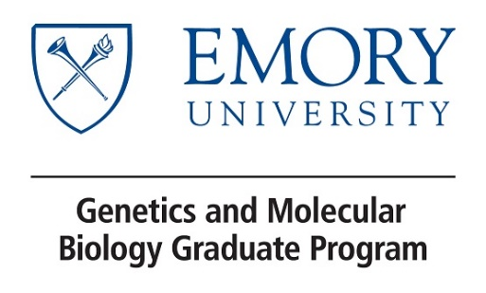

GMB Rotation Agreement Form: 2021 – 2022

This form must be submitted to the DGS for approval prior to the beginning of the rotation.

Student: ______________________________________________________________

Rotation Advisor: _______________________________________________________

Rotation Period:

- First Rotation: September 13 to October 29, 2021 ___In-Person ___Online ___Both
- Second Rotation: November 8 to December 23, 2021 ___In-Person ___Online ___Both
- Third Rotation: January 10 – March 31, 2022 ___In-Person ___Online ___Both
- Fourth Rotation: April 4 – May 27, 2022 ___In-Person ___Online ___Both

Briefly describe one or two objectives of the project.

Please outline the expectations for participation in the lab:

Are there specific hours to be spent in the lab/dedicated to the research or an average number of hours per week?

How frequently will the student and mentor (either the PI or senior lab member) meet to discuss progress on the project?

What is the preferred mode of research documentation (i.e lab notebooks)?

What is the preferred mode of communication (i.e. email, phone, Slack, etc) and response time?

At the end of each rotation, students will prepare and present a short (10-15 min) research presentation describing the rotation project, including the appropriate background for the research question, a brief description of the methods used, any data collected (negative or positive), limitations of the experiment, and future directions. Rotation advisors should help with preparing this presentation and are invited to attend. At the end of the rotation, both the student and the head of the rotation lab will complete an evaluation form assessing the experience. The faculty evaluation and the research presentation will be used in the determining the students’ final grade.

As stated in the GMB guidelines: “No GMB faculty may accept more than a total of three GMB rotation students per academic year, and have not more than two doctoral students from any graduate program rotating in their lab within any rotation period. Students may elect to rotate in additional labs but must select a laboratory for their dissertation research before the start of their second year. Exceptions must be approved by the Executive Committee and Program Director (Dr. Danny Reines).”

By signing below, I certify that I understand and adhere to the policies outlined above.

Student signature: Date:

Rotation Advisor signature: Date:

DGS signature: Date:

